
Report 1

Team ID | MCA
Project Name | Strategic Employee Attrition Intelligence Dashboard
Maximum Marks | 5 Marks

A report is a comprehensive document that provides a detailed and structured account of data analysis, findings, and insights. It is typically used for in-depth analysis, documentation, and communication of results. Reports are suitable for a diverse audience, including decision-makers, analysts, and stakeholders who need a comprehensive understanding of the data.
Designing a report in Power BI involves connecting to data sources, creating visualizations like charts and graphs, customizing their appearance and interactivity, organizing them logically on the canvas, formatting elements for consistency and clarity, and optionally creating dashboards for a summarized view. Throughout the process, it's essential to consider the audience's needs and ensure the report effectively communicates insights from the data. Finally, iterate based on feedback to continually improve the report's design and usefulness and trends
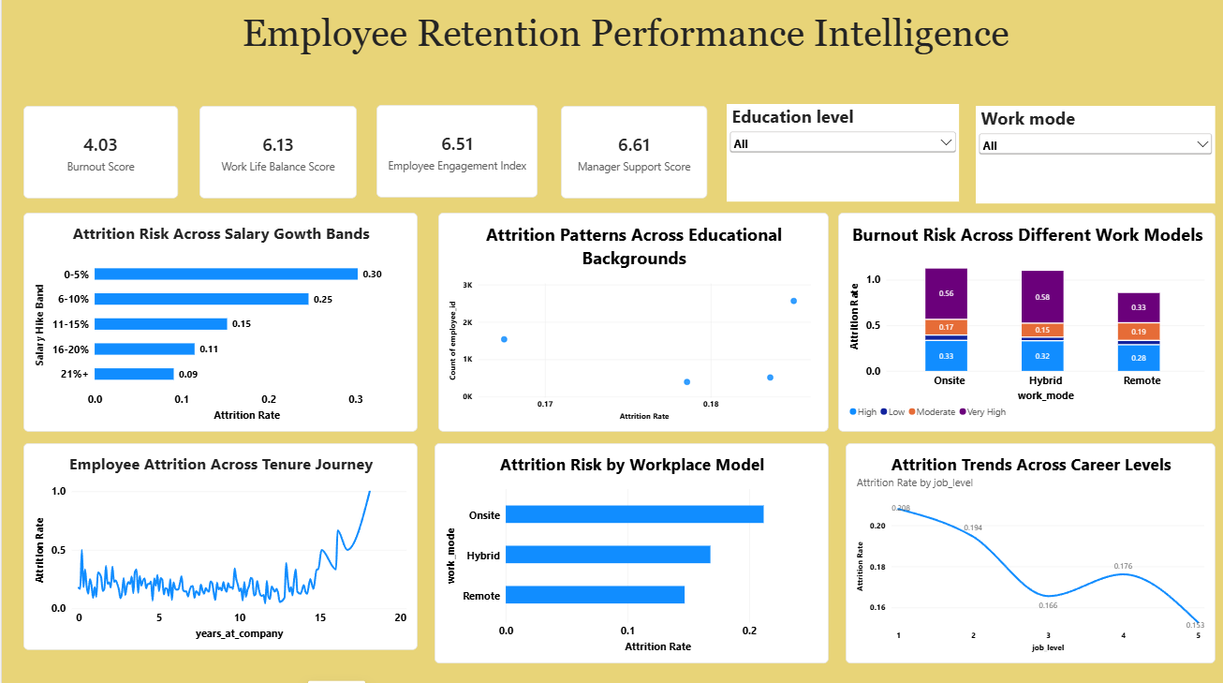
1. Trends Over Time
The dashboard analyzes employee attrition across the tenure journey to understand how attrition changes as employees spend more years with the organization.
- The Employee Attrition Across Tenure Journey chart shows fluctuations in attrition rates throughout employees' years at the company.
- Attrition remains relatively variable during the early and middle stages of tenure.
- A noticeable increase can be observed toward the later years of the tenure journey.
- This indicates that employee retention should be monitored throughout the employee lifecycle, particularly among employees with longer tenure.
2. Performance Comparisons
The report compares attrition rates across different salary growth bands and workplace models.
Salary Growth Analysis
The Attrition Risk Across Salary Growth Bands chart shows:
- 0–5% salary growth has the highest attrition rate at approximately 0.30.
- 6–10% salary growth has an attrition rate of approximately 0.25.
- 11–15% shows approximately 0.15.
- 16–20% shows approximately 0.11.
- 21%+ has the lowest observed attrition rate at approximately 0.09.
This shows a clear difference in attrition rates across salary-growth categories. The lower salary-growth bands in this dataset are associated with higher observed attrition rates.
Workplace Model Analysis
The Attrition Risk by Workplace Model visual compares employees working under different workplace arrangements:
- Onsite: approximately 0.21
- Hybrid: approximately 0.17
- Remote: approximately 0.15
The dashboard therefore shows different levels of observed attrition across onsite, hybrid, and remote work models.
3. Employee Segmentation
The dashboard segments employees using factors such as educational background, career level, work mode, salary growth, and tenure.
The Attrition Patterns Across Educational Backgrounds visual allows HR teams to compare attrition rates with employee educational backgrounds and employee counts. This can help identify whether particular educational groups show different workforce-retention patterns.
Similarly, the Attrition Trends Across Career Levels chart shows changes in attrition across job levels:
- Job Level 1: approximately 0.208
- Job Level 2: approximately 0.194
- Job Level 3: approximately 0.166
- Job Level 4: approximately 0.176
- Job Level 5: approximately 0.153
These values indicate that attrition varies across career levels, with the dashboard showing a lower rate at the highest career level compared with the lower levels.
4. Employee Well-being and Retention Indicators
The KPI cards provide an overview of important employee experience indicators:
- Burnout Score: 4.03
- Work-Life Balance Score: 6.13
- Employee Engagement Index: 6.51
- Manager Support Score: 6.61
These indicators provide additional context for understanding employee retention. Burnout, work-life balance, engagement, and manager support can be examined alongside attrition patterns to identify areas requiring further HR analysis.
5. Burnout Risk Across Work Models
The Burnout Risk Across Different Work Models visual compares burnout-risk categories across onsite, hybrid, and remote employees.
The chart includes High, Low, Moderate, and Very High burnout-risk categories. This allows HR teams to examine whether burnout-risk patterns differ according to workplace arrangements.
Combining this visual with the Attrition Risk by Workplace Model chart provides a broader view of the relationship between work arrangements, employee well-being, and retention.
6. Key Outcomes from the Dashboard
The major outcomes identified from the Employee Retention Performance Intelligence dashboard are:
- Salary Growth and Attrition: Employees in the 0–5% salary-growth band show the highest attrition rate of approximately 30%, while the 21%+ band shows approximately 9%.
- Workplace Model: The observed attrition rate is approximately 21% for onsite employees, 17% for hybrid employees, and 15% for remote employees.
- Career-Level Variation: Attrition varies across job levels, ranging from approximately 15.3% to 20.8% in the displayed data.
- Employee Engagement: The dashboard reports an Employee Engagement Index of 6.51, providing an overall indicator of employee engagement.
- Manager Support: The Manager Support Score is 6.61, indicating the measured level of perceived managerial support in the dataset.
- Work-Life Balance: The Work-Life Balance Score is 6.13, which can be considered alongside attrition and burnout indicators when analyzing employee retention.
- Burnout: The Burnout Score is 4.03, while the work-model visualization shows differences in burnout-risk categories across onsite, hybrid, and remote employees.
- Tenure: Attrition fluctuates across employees' tenure at the company, with a noticeable increase toward the later years shown in the visualization.
7. Overall Insight
The Employee Retention Performance Intelligence dashboard demonstrates that employee attrition varies across several workforce characteristics, including salary growth, workplace model, career level, educational background, and tenure. The dashboard also incorporates employee-experience indicators such as burnout, work-life balance, engagement, and manager support.
These insights can help HR teams identify employee groups with different observed attrition patterns and investigate the underlying factors contributing to retention challenges. The report can therefore support data-driven employee-retention analysis, workforce planning, and targeted HR investigation.
Report 2
Team ID | MCA
Project Name | Strategic Employee Attrition Intelligence Dashboard
Maximum Marks | 5 Marks
Employee Performance Career Growth Intelligence :
The Employee Performance Career Growth Intelligence report provides a comprehensive analysis of employee performance, career development, overtime, training investment, retention, and departmental attrition. The Power BI report helps HR teams understand how employee performance and career-related factors are associated with employee retention and attrition.
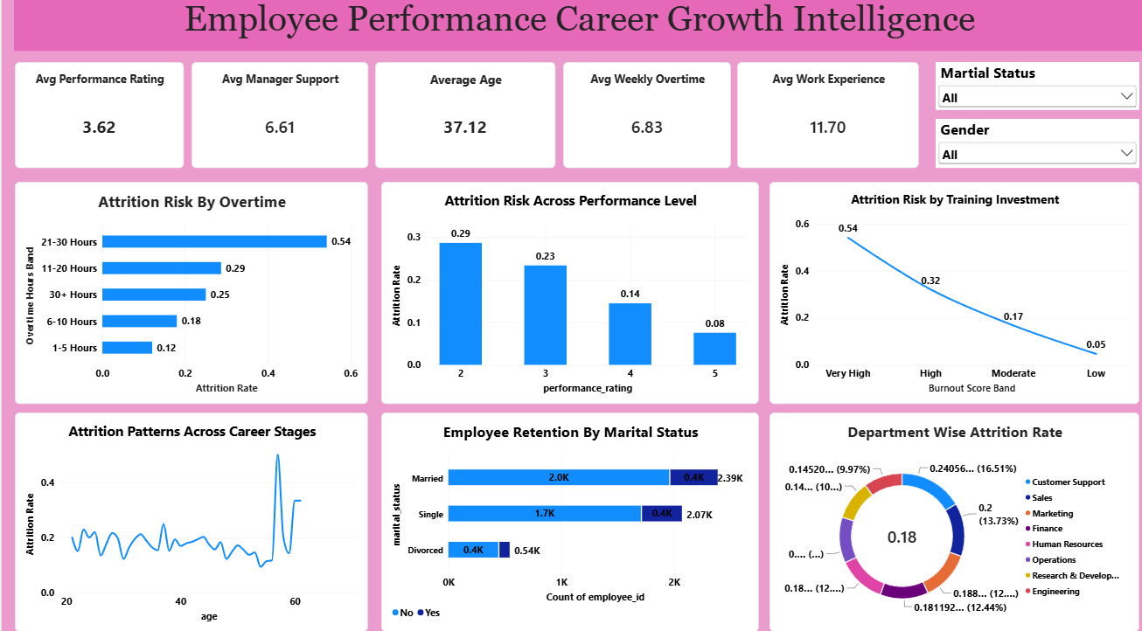
1. Performance and Employee Overview
The report provides key indicators about the overall employee workforce:
- Average Performance Rating: 3.62
- Average Manager Support: 6.61
- Average Employee Age: 37.12 years
- Average Weekly Overtime: 6.83 hours
- Average Work Experience: 11.70 years
These KPIs provide an overview of employee performance, managerial support, workforce demographics, workload, and experience.
2. Attrition Risk by Overtime
The Attrition Risk by Overtime chart shows that attrition varies considerably according to weekly overtime hours.
- 21–30 hours: 0.54
- 11–20 hours: 0.29
- 30+ hours: 0.25
- 6–10 hours: 0.18
- 1–5 hours: 0.12
The highest observed attrition rate is among employees working 21–30 hours of overtime, at approximately 54%. Employees in the 1–5 hours overtime category show the lowest observed rate at approximately 12%.
3. Attrition Risk Across Performance Levels
The report compares attrition across employee performance ratings.
- Performance Rating 2: 29%
- Performance Rating 3: 23%
- Performance Rating 4: 14%
- Performance Rating 5: 8%
The visualization shows a decline in observed attrition as the performance rating increases. Employees with a performance rating of 2 have the highest displayed attrition rate, while employees rated 5 have the lowest.
4. Attrition Risk by Training Investment
The Attrition Risk by Training Investment chart shows differences in attrition across burnout-score bands:
- Very High: 54%
- High: 32%
- Moderate: 17%
- Low: 5%
The displayed data shows that the Very High category has the highest observed attrition rate, while the Low category has the lowest. This visualization can help HR investigate the relationship between employee well-being, training-related factors, and retention.
5. Attrition Patterns Across Career Stages
The Attrition Patterns Across Career Stages chart examines attrition across employee ages.
The attrition rate fluctuates across different age groups. Most displayed values remain within a relatively lower range, but a noticeable increase occurs around the later career stage shown in the chart.
This analysis can help HR examine whether retention patterns differ across various stages of an employee's career.
6. Employee Retention by Marital Status
The report also compares employee retention according to marital status.
- Married employees: approximately 2.39K
- Single employees: approximately 2.07K
- Divorced employees: approximately 0.54K
The visualization separates employees according to retention status, allowing HR teams to compare the number of employees who remained with the organization and those who left across different marital-status groups.
7. Department-Wise Attrition Rate
The Department Wise Attrition Rate chart provides a comparison of attrition across organizational departments.
The overall attrition rate displayed in the center of the chart is approximately 0.18 (18%).
The chart includes departments such as:
- Customer Support
- Sales
- Marketing
- Finance
- Human Resources
- Operations
- Research & Development
- Engineering
This visualization helps identify differences in attrition across departments and allows HR teams to investigate departments where employee turnover requires further attention.
Key Outcomes from the Report
The major outcomes identified from the Employee Performance Career Growth Intelligence dashboard are:
- Overtime and Attrition: The 21–30 hours overtime group has the highest observed attrition rate of 54%, compared with 12% for employees working 1–5 hours of overtime.
- Performance and Attrition: Attrition decreases across the displayed performance levels, from 29% at rating 2 to 8% at rating 5.
- Burnout-Score Bands: The Very High burnout-score band has an observed attrition rate of 54%, while the Low band has approximately 5%.
- Overall Workforce Performance: The average employee performance rating is 3.62, providing an overall measure of performance across the workforce.
- Manager Support: The average manager support score is 6.61, indicating the measured level of managerial support in the dataset.
- Workload: Employees work an average of 6.83 hours of overtime per week, which provides an important workload indicator for retention analysis.
- Work Experience: The average employee has approximately 11.70 years of work experience.
- Marital Status: The dashboard shows approximately 2.39K married employees, 2.07K single employees, and 0.54K divorced employees, with retention status further segmented within each group.
- Departmental Attrition: The overall displayed departmental attrition rate is approximately 18%, with variations across the different departments.
Overall Insight
The Employee Performance Career Growth Intelligence report provides a detailed view of the relationship between employee performance, workload, career stage, training/burnout-related categories, managerial support, and employee retention. The dashboard indicates substantial variation in observed attrition across overtime groups, performance ratings, career stages, and departments.
These insights can help HR teams identify employee groups with different retention patterns, monitor workload and performance indicators, examine departmental differences, and support data-driven workforce planning and career-development strategies.

